**Create TEXTMODULE and use it in smart forms**

1) Go to tcode smartforms. Choose the TextModule Radio button. Give a name starting with Z/Y. Click on Create

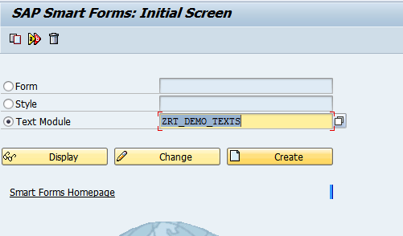

2) Enter any text. 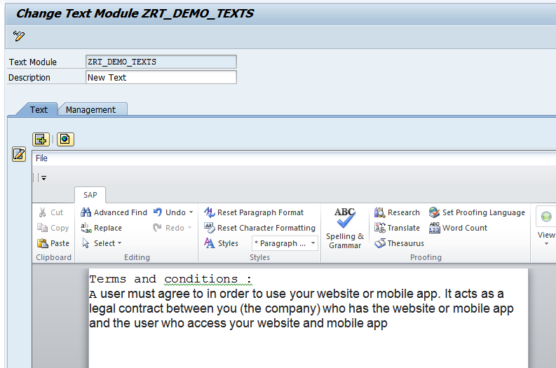

3) Save the Text Module. Go back

4) Open any smartform created earlier. **Change the text type to TEXTMODULE**

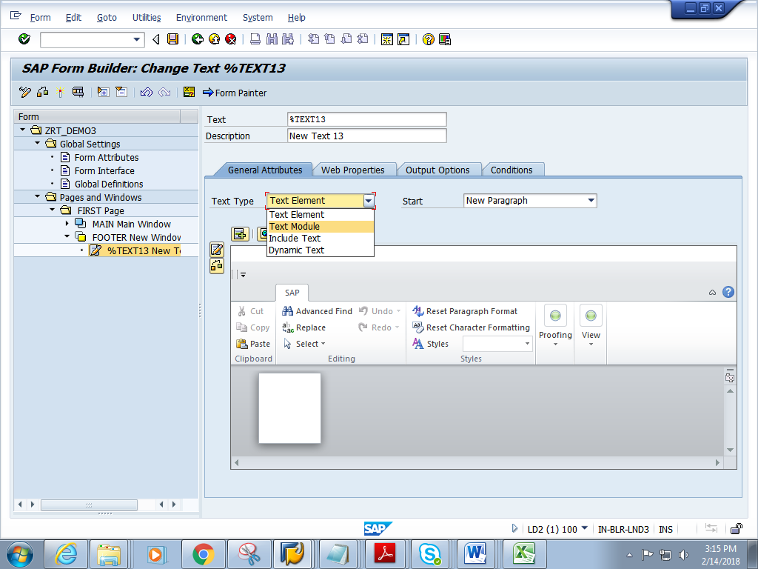

5) Give the name of the text module created earlier

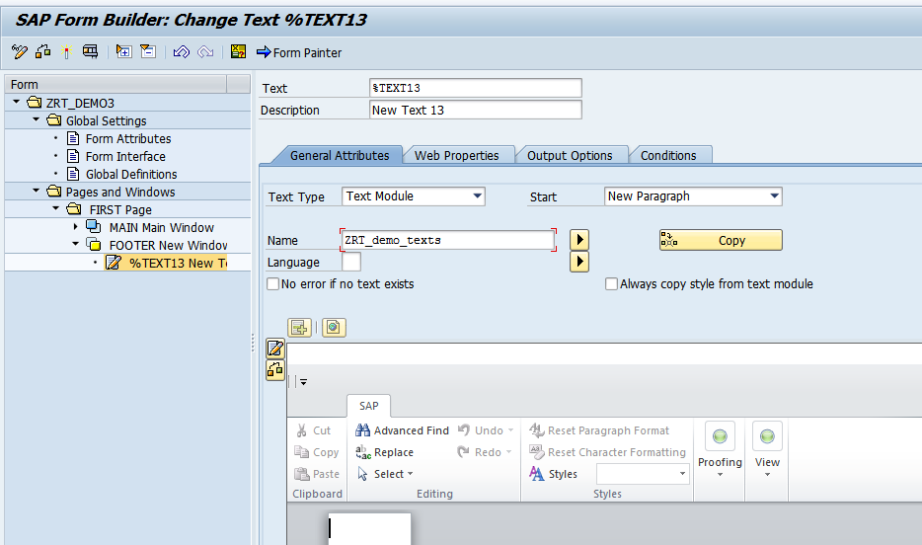

6) Save and activate the form

7) Click on Print preview

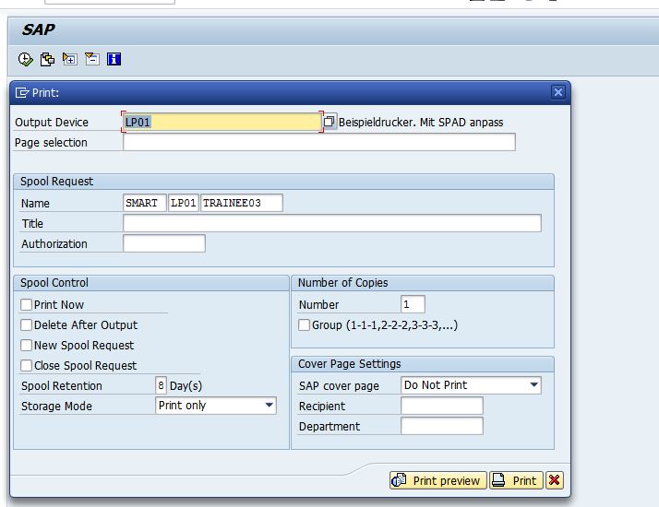

8) Expected output is as follows.

